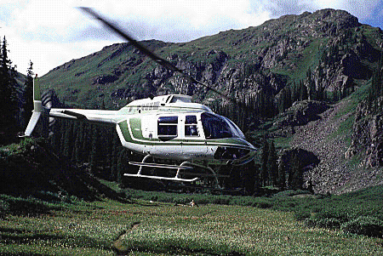

Version

3.0 1.0

CAVU Companies Copyright 1999 All rights reserved
Operating Manual

Tracker

Maintenancennance

Table of Contents
General 3
Technical Support 3
A Message To Our Customers 3
End-User License Agreement 4
Overview 5
INSTALLATION 6
Set-up 6
Company Information & Setup Screen 7
Aircraft Set-up 9
Selecting an Aircraft 9
Airframe Times 9
Components 10
- Item Number 10
- Installed 10
- Meter 10
- Assembly 10
- Manufacturer 10
- Reserve per Hour 10
- Service Life and Basis 10
- Oil Analysis 11
Deleting Aircraft 11
Forecast times 12
Customizing 12
- Show 12
- Report 12
Printing 13
Oil Analysis 14

General

TECHNICAL SUPPORT
CAVU products come with 90 days of free telephone technical support from the date of the invoice. To contact technical support, call CAVU Companies between 9AM and 5PM Eastern time at :
1-315-732-9088
Please Note: In order to provide continuing and quality support to all of its customers, CAVU follows a strict adherence to this policy. Telephone support will be provided only to those currently covered by the support program appropriate for the product requiring support. CAVU maintains an internet homepage at:
www.cavucompanies.com
which contains many of the common questions or problems customers encounter. Access to the CAVU website is free.
Annual support is obtained through CAVU at a nominal charge. Updates to existing product versions will be sent automatically to customers currently on support.

A MESSAGE TO OUR CUSTOMERS
The products described in this manual are specifically designed for the aircraft maintenance industry. This is a relatively small market for which to exclusively develop software, particularly for the “off the shelf” pricing at which these products are sold. Illegally copied or “pirated” software undermines the stability of this company and thus threatens the continued development and support of products designed exclusively for your business. We appreciate and encourage your support in this campaign. Thank you for your patronage.

End-User License Agreement
FOR CAVU COMPANIES SOFTWARE
IMPORTANT- READ CAREFULLY: This CAVU Companies End-User License Agreement (LICENSE AGREEMENT) is a legal agreement between you and CAVU Companies for the CAVU Companies product identified on the enclosed diskette label, which includes computer software, printed material, associated media or electronic documentation (“SOFTWARE PRODUCT”). By installing, copying, or otherwise using the SOFTWARE PRODUCT, you agree to be bound by the terms of this . If you do not agree to the terms of this agreement, DO NOT OPEN THIS ENVELOPE, INSTALL OR COPY THE SOFTWARE PRODUCT; you may, however, return the unopened ENVELOPE to your place of purchase for a refund, subject to restocking and shipping charges.
The SOFTWARE PRODUCT is protected by copyright laws and international copyright treaties, as well as all other intellectual property laws and treaties. The SOFTWARE PRODUCT is licensed, NOT SOLD.
GRANT OF LICENSE: This LICENSE AGREEMENT grants you the following rights:
CAVU Companies grants to you as an individual, a personal, nonexclusive license to use the SOFTWARE PRODUCT on one computer. You may store or install a copy of the SOFTWARE PRODUCT on a storage device, such as a network server, used only to install or run the SOFTWARE PRODUCT on your other computer (workstation) over an internal network; however, you must acquire and dedicate a license for each separate computer (workstation) on which the SOFTWARE PRODUCT is installed or run from the storage device. If the SOFTWARE PRODUCT is run directly from the server, a license must be acquired for each workstation that will run the SOFTWARE PRODUCT. A license for the SOFTWARE PRODUCT may not be shared or used concurrently on different computers.
Electronic and Printed Documents may be copied, either in hardcopy or electronic form, provided that such copies shall be used for internal purposes and are not republished or distributed to any third party.
DESCRIPTION OF OTHER RIGHTS AND LIMITATIONS:
You may not reverse engineer, decompile, reserve compile or disassemble the SOFTWARE PRODUCT, except and only to the extent that such activity is expressly permitted by applicable law notwithstanding this limitation.
You may not rent, lease, or lend the SOFTWARE PRODUCT.
You may not transfer any rights of this license.
If the SOFTWARE PRODUCT is labeled as an upgrade, you must be properly licensed to use a product identified by CAVU Companies as being eligible for the upgrade in order to use the SOFTWARE PRODUCT. A SOFTWARE PRODUCT labeled as an upgrade replaces and/or supplements the product that formed the basis for your eligibility for the upgrade. You may use the resulting upgraded product only in accordance with the terms of this LICENSE AGREEMENT. If the SOFTWARE PRODUCT is an upgrade of a component of a package of software programs you licensed (version change) as a single product, the SOFTWARE PRODUCT may be used and transferred only as part of that single product package and may not be separated for use on more than one computer.
CAVU Companies may, without prejudice to any other rights, terminate this LICENSE AGREEMENT, if you fail to comply with the terms and conditions of this LICENCE AGREEMENT. In such event, you must destroy all copies of the SOFTWARE PRODUCT and all of its components and documentation.
COPYRIGHT: All title and copyrights in and to the SOFTWARE PRODUCT (including but not limited to any images, photographs, animations, video, audio, music and text incorporated into the SOFTWARE PRODUCT), the accompanying printed materials, and any copies of the SOFTWARE PRODUCT are owned by the CAVU Companies. The SOFTWARE PRODUCT is protected by copyright laws and international treaty provisions. Therefore, you must treat the SOFTWARE PRODUCT like any other copyrighted material except that you may install the SOFTWARE PRODUCT on a single computer provided you keep the original solely for backup or archival purposes. You may not copy the printed materials accompanying the SOFTWARE PRODUCT except as provided above.
DUAL MEDIA SOFTWARE: You may receive the SOFTWARE PRODUCT in more than one medium. Regardless of the size or type of medium, you may use only one medium that is appropriate for you computer. You may not use or install the other medium on another computer. You may not loan, rent, lease or otherwise transfer the other medium to another user.
U.S. GOVERNMENT RIGHTS: The SOFTWARE PRODUCT and documentation are provided with RESTRICTED RIGHTS. Use, duplication, or disclosure by the Government is subject to restrictions as set forth in subparagraph (C)(1)(ii) of the Rights in Technical Data and Computer Software clause at DFARS 252.227-7013 or subparagraph (c)(1) and (2) of the Commercial Computer Software-Restricted Rights at 48 CFR 52.227-19, as applicable. Manufacturer is CAVU Companies/1001 Broad Street/Utica, NY 13501.
This LICENSE AGREEMENT is governed by the laws of the state of New York.
LIMITED WARRANTY: CAVU Companies warrants that the SOFTWARE PRODUCT will perform substantially in accordance with the accompanying written materials for a period of ninety (90) days from the date of receipt and any support services provided by CAVU Companies shall be substantially as described in applicable written materials provided to you by CAVU Companies and CAVU Companies support representatives will make commercially reasonable efforts to solve any problem issues.
NO OTHER WARRANTIES: TO THE MAXIMUM EXTENT PERMITTED BY APPLICABLE LAW, CAVU COMPANIES DISCLAIM ALL OTHER WARRANTIES AND CONDITIONS, EITHER EXPRESSED OR IMPLIED, INCLUDING, BUT NOT LIMITED TO, IMPLIED WARRANTIES OR MERCHANTABILITY, FITNESS FOR A PARTICULAR PURPOSE, TITLE AND NON-INFRINGEMENT, WITH REGARD TO THE SOFTWARE PRODUCT, AND THE PROVISION OF OR FAILURE TO PROVIDE SUPPORT SERVICES.
LIMITATION OF LIABILITY: TO THE EXTENT PERMITTED BY APPLICABLE LAW, IN NO EVENT SHALL CAVU COMPANIES BE LIABLE FOR ANY SPECIAL, INCIDENTAL, INDIRECT, OR CONSEQUENTIAL DAMAGES WHATSOEVER (INCLUDING, WITHOUT LIMITATION, DAMAGES FOR LOSS OF BUSINESS PROFITS, BUSINESS INTERRUPTION, LOSS OF BUSINESS INFORMATION, OR ANY OTHER PECUNIARY LOSS) ARISING OUT OF THE USE OF OR INABILITY TO USE THE SOFTWARE PRODUCT OR THE PROVISION OF OR FAILURE TO PROVIDE SUPPORT SERVICES, EVEN IF CAVU COMPANIES HAS BEEN ADVISED OF THE POSSIBILITY OF SUCH DAMAGES. IN ANY CASE, CAVU COMPANIES’ ENTIRE LIABILITY UNDER ANY PROVISION OF THIS LICENSE AGREEMENT SHALL BE LIMITED TO THE GREATER OF THE AMOUNT ACTUALLY PAID BY YOU FOR THE SOFTWARE PRODUCT OR US$1.00.

OVERVIEW
Maintenance Tracker© provides an easy to use, management tool to track and project component lives, recurring inspections, Service Bulletins and Airworthiness Directives. The software can also be used to track and graphically display oil analysis results. The program uses a simple “point and click” interface.
This program must be installed on a computer system with the following:
- Microsoft Windows 95/98/NT. Please read the license agreement regarding your rights and responsibilities. Workstations require individual licenses.
- Microsoft DOS compatible computer
- SVGA monitor (800x640 resolution or higher must be set with Small Fonts.)
- Pentium processor
- Inkjet, Bubblejet or Laser printer supported by Windows. It is the user’s responsibility to provide proper installation and drivers.
- Windows compatible mouse
- Compatible RAM for system
- 10 MB free hard disk space

INSTALLATION

Set-up
NOTICE: See the Troubleshooting Guide for rarely encountered issues.
- From the START button select RUN from the pull-down list.
- At the prompt, enter A:SETUP. Note A: refers to the drive where the diskette is placed. If your drive is designated B: then substitute B: in place of A:. Note: you must enter the correct drive.
- The installation allows the placement of Maintenance Tracker© within any subdirectory. The default subdirectory is C:\MTracker. Follow the screen prompts to complete the installation.
- Maintenance Tracker© installation is now complete. The installation should have created a new grouping within Programs entitled Desk Manager Series. Within the Desk Manager group are Maintenance Tracker© and Data Manager icons.
- Double click on the Maintenance Tracker© icon to start the program.
- The company information and set-up screen appears when entering the program for the first time. Proceed with the Company Information & Setup section within this manual.

COMPANY INFORMATION & SETUP SCREEN
The company information and set-up screen appears when entering the program for the first time or when you click on the COMPANY SETUP button. You must have in your possession the registration code supplied with your software before proceeding. The code appears on the envelop containing the software diskettes and on your invoice.
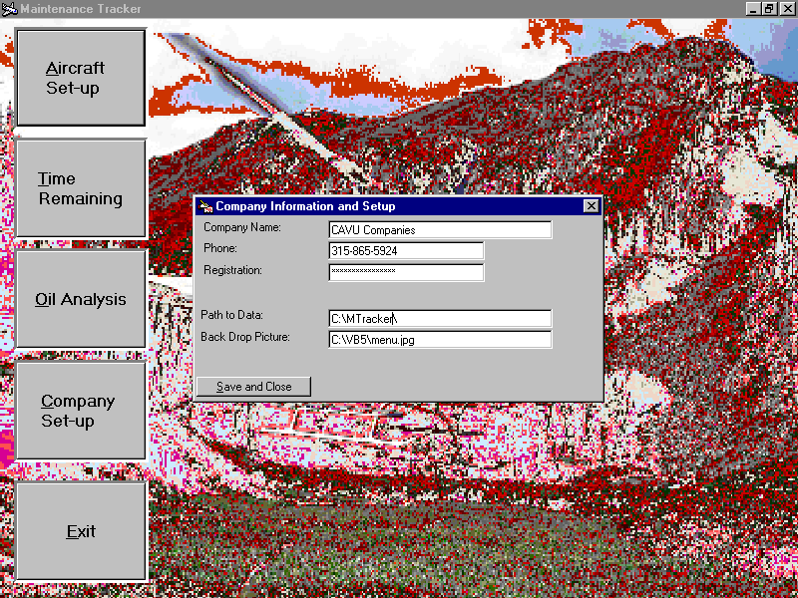
- Enter the company name.
- Enter your company’s telephone number as it appears on the registration tag attached to the envelop containing the software diskettes or invoice. You may use separators i.e. ( ) - or / to separate numbers. Enter the complete number including area code but do not precede the number with a “1” and do not leave blank. For example:

1-315-555-1212 WRONG
(315) 555-1212 CORRECT
- Enter the registration code as it appears on the registration attached to the envelop containing the software diskettes. The code also appears on your invoice. Retain the envelop for future reference. If you have questions with this aspect of the installation, call CAVU Companies for support at 1-315-865-4923.
- Click within the Path to Data field. A file/directory/drive list box appears. Locate the TIMEMGR.MDB file box in the left hand panel. If the file does not appear within the window, you may need to change the subdirectory by clicking within the LOOK IN pull-down list or pressing the UP FOLDER button. Once located, click on the file and then OPEN. To abort, click on cancel.
- Optional: Click within the Backdrop picture field to change the picture displayed. A file/directory/drive list box appears. Locate the picture to display. If you change the default picture, you will only be able to display the default picture by re-installing the software. If the file does not appear within the window, you may need to change the subdirectory by clicking within the LOOK IN pull-down list or pressing the UP FOLDER button. Once located, click on the file and then the OPEN button. To abort, click on the CANCEL button.
- When finished, click on the SAVE & CLOSE button. If all entries are acceptable, the MAIN screen appears. If not, a message describing the discrepancy appears and the Company Information screen remains active.
To begin, go to the AIRCRAFT SETUP section.

Aircraft Set-up

Select AIRCRAFT SETUP from the main screen. Within the new screen, either select an existing aircraft registration number from the pull-down list or add a new aircraft.
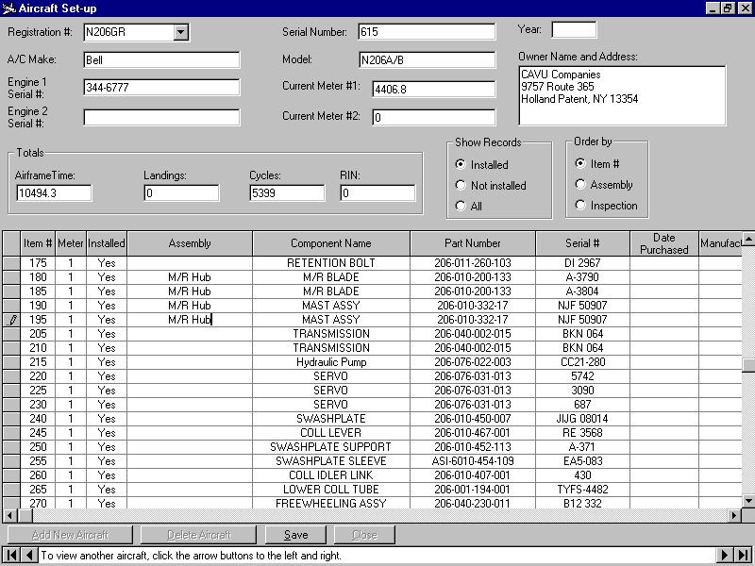

Selecting an Aircraft
To add a new aircraft, begin by clicking the NEW AIRCRAFT button and then entering the registration number in the upper left hand corner. To view an existing aircraft, select from the pull-down list.
Enter information in all appropriate fields.

Airframe Times
Airframe times can be entered by three methods. The first is to simply change the meter reading from the old reading to the new reading. Pressing ENTER or moving off the field with the mouse will generate a confirmation box which displays the calculated time increase. If this is correct, press YES and the Aircraft Total time field will change accordingly. If you respond with NO, a second prompt will appear to allow the user to reset the time displayed without further calculations. If a new meter is installed, enter 0.
The second way to change the aircraft time is to enter the number of hours for the flight by preceding the number with a plus sign (+). For example, entering +1.3, will increase the meter and the aircraft total time by 1.3 hours. Again, a confirmation message will appear.
The last method is to change the Aircraft Total Time field. This method works like the methods above, however, changes do not alter the meter reading and a confirmation prompt will not display when using the + sign method.
Save your data whenever the SAVE button is active.

Components
To modify existing components, simply place the cursor in the grid below at the level of the item. To enter a new item, move to the last line in the grid (an asterisk symbol is seen in the left margin).

Item Number
Enter an item number for the component. Some users like to increment this number by 5 or 10 to allow proper ordering of late additions. The list may be sorted by the item number or grouped by assembly or inspection.

Installed
Enter whether the item is currently installed in the aircraft by toggling (double clicking) the value to Yes or No, or typing Y or N respectively. An overhauled part can either be entered as a new item (making one installed and the other not) or by modifying the one.

Meter
Enter which meter the item is based on.

Assembly
The Assembly field refers to the major component associated with the item being entered (i.e.,Transmission). Likewise, the Inspection field can be filled in with the inspection associated with the item, i.e. Phase 8 check or Annual. Both the assembly and inspection fields can be left blank.

Manufacturer
The Manufacturer field receives an automatic entry equal to the aircraft manufacturer, but can be overwritten.

Reserve per Hour
The Reserve per Hour field is a calculated field based on the Cost to Replace entry and the Service Life of the part.

Service Life and Basis
Service Life is the number relating to the interval for the retirement, overhaul or inspection. It is entered as a number only. The Type field is a two letter entry corresponding to the action as follows:

Type | Action to take at Service Life | Based on
RT | Retire | TT Hours
OH | Overhaul | TT Hours
IN | Inspect | TT Hours
RN | Retire | RINs
LD | Retire | Landings
CY | Retire | Cycles
MO | Retire | Months

If inspections or overhauls are based on landings, cycles, RIN or months, disregard any reference to retirement on the printouts for these items.

The Component at Install allows the entry of “used” parts within an aircraft. Component at Install is the number of hours, cycles etc. on the part at the time of its installation. This will be 0 for new parts. Remember to enter the hours, cycles, landings or RINs on the part, not the time remaining on the part at the time of installation.

Depending upon the type of service life (RT, OH etc), enter the A/C at Install value as either the Total Time, Cycles, Landings or RINs on the aircraft when the part was installed. This entry is not used for MO type items.

Oil Analysis
Oil Analysis is a Yes/No toggle used to distinguish those items which an oil analysis may be performed. It must be set to Yes if the item is to appear within the Oil Analysis section. Toggle the entry by double clicking the box or typing the letter Y or N.

The part description is displayed by clicking within the grid on the line in question. To highlight an entire line, click in the left margin (gray) of the grid.

Deleting Aircraft
To delete an aircraft, press the DELETE AIRCRAFT button on the bottom of the screen. To delete an item, place the cursor on the line to be removed. Click on the left margin (gray) adjacent to the item so that the entire line is highlighted, then press the keyboard Delete key.

Remember to press the SAVE button when enabled.

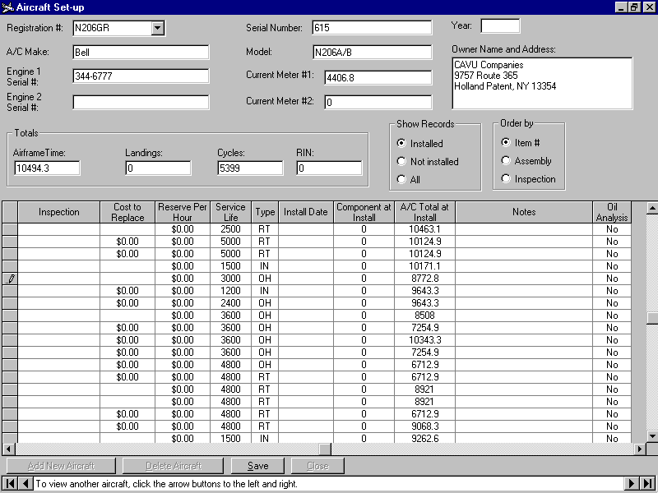
Time Remaining

Select TIME REMAINING from the main screen. Within the new screen, select an existing aircraft registration from the pull-down list.
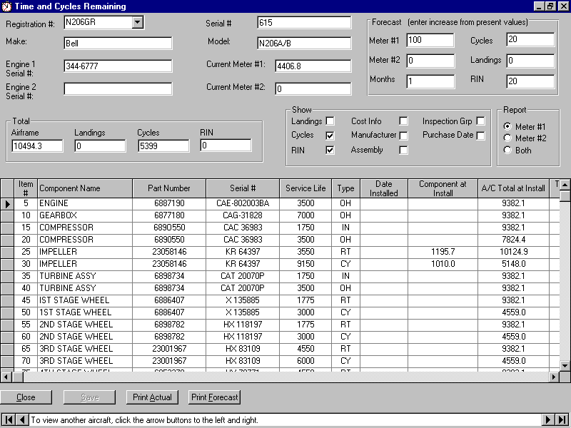
The aircraft information will appear as saved the last time the aircraft was viewed.

Forecast times
Forecast times can be entered for each aircraft. These numbers are used to calculate a time remaining report based on forecasted usage. The numbers are saved with the aircraft so that forecast reports can be quickly displayed and printed. The entries represent forecasted usage in hours, cycles, landings and RINs, not total times. The month entry is used only as a reference for the time interval being projected.

Customizing

Show
The Show frame contains checkboxes that allow the user to customize how each aircraft is displayed on screen. Some aircraft don’t utilize landings as a type of inspection interval, therefore, the landings column can be hidden by un-checking the checkbox. The user may wish to view other columns by checking the appropriate checkbox.

Report
The Report frame toggles which of the components are displayed. Those based on meter #1, meter #2 or both are displayed dependent upon the option button selected.

The grid section can not be edited in this screen as the numbers are calculated. Meters and cumulative times can be edited however.
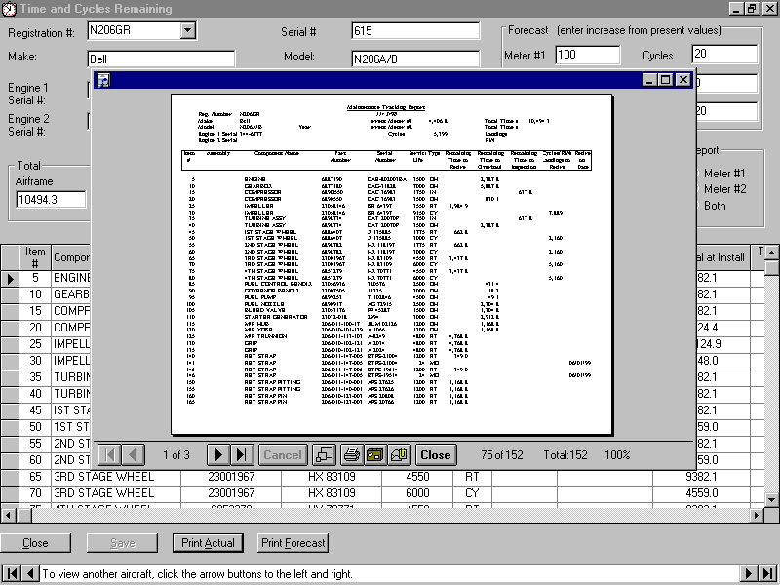

Printing
Printing actual or forecasted reports can be performed by displaying the aircraft desired and clicking the appropriate button. A print preview will appear on the screen. It may be viewed and zoomed to fill the entire screen by clicking the zoom button (3 small boxes). Press the printer button to begin printing. Number of copies and other printer options will appear prior to printing.

Oil Analysis

Select OIL ANALYSIS from the main screen. Within the new screen, select an existing aircraft from the pull-down list. If a part has been identified as an oil analysis item, it will appear in the lower pull-down list. The first item is selected automatically. To select another item, use the lower pull-down list. The grid will display analyses by date. To enter a new oil analysis, move to the last line in the grid (and asterisk symbol is seen in the left margin) and begin typing the date. Enter values for each component tested. Values that are reported as <1 should be entered as 0. After saving the data, the chart will update with the last ten analyses.
To view separate elements, use the option buttons above. Phosphorus is displayed separately because its scale dwarfs the other elements.
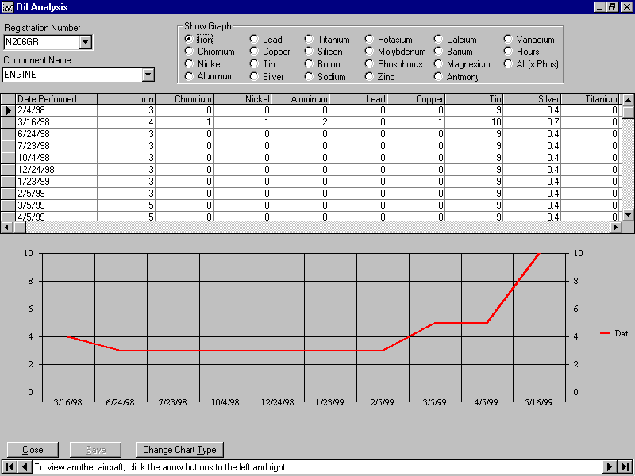

Troubleshooting Guide
Problem | Solution
Keeps asking me for my registration code. | When installing the program, you are asked to enter your telephone number as it appears on your invoice. Notice that the number is not preceded by a “1”.  If the phone number was listed correctly, the registration code must be entered as shown on the invoice.
MDB is not an Access database or database is corrupt | This message appears when the program has been exited improperly. From the Desk Manager Series group, double click on DATA MANAGER. In the upper left hand corner, select REPAIR DATABASE from the FILE pull-down list. In the left window, below “*.MDB”, the file name should appear. If you use multiple programs from CAVU, the default file may be different than the file which is corrupt. If the correct file appears, click on it once, otherwise, double click on the “C:\” in the right window and using the scroll bar, select the appropriate subdirectory for the file, i.e. C:\MTracker. The correct file should now appear in the window on the left. Click on it once, then click on OK. When the screen blanks, select EXIT from the FILE pull-down list. You may now re-start your program.
“Reserved Error” - No message for this error | This error may appear when the user attempts to repair the database and re-enter the program. The error signifies that the database must be compacted. To begin, follow the procedure above under “MDB is not an Access database or database is corrupt” to repair the database.  From the Desk Manager Series group, double click on DATA MANAGER. In the upper left hand corner, select COMPACT DATABASE from the FILE pull-down list. In the left window, below “*.MDB”, the file name should appear. If you use multiple programs from CAVU, the default file may be different than the file which is corrupt. If the correct file appears, click on it once, otherwise, double click on the “C:\” in the right window and using the scroll bar, select the appropriate subdirectory for the file, i.e. C:\MTracker. The renamed file should now appear in the window on the left (“TimeMgr.MDB”). Click on it once, then click on OK. The screen should now be titled DATABASE TO COMPACT TO. Enter NEW.MDB. When the screen blanks, select EXIT from the FILE pull-down list.  Then from Windows Explorer (Win 95) go to the subdirectory where the program resides (i.e. C:\MTracker). Find the file on the right side named NEW.MDB (Note: if using Win 95 click on VIEW, OPTIONS and make sure that the “HIDE MS-DOS extensions ...” check box is not checked and that “Show all files..” is checked.)  Right Click on the MDB file so that it is highlighted and Rename the file to TimeMgr.MDB. DO NOT rename any file with SETUP in its name.  You may now restart your program

