Version

3.0 1.0

CAVU Companies Copyright 1999 All rights reserved
Operating Manual

Labeler

Logbook

Table of Contents
General 4
Technical Support 4
A Message To Our Customers 4
End-User License Agreement 5
Overview 6
INSTALLATION 7
Setup 7
Installing Fonts 8
Share.Exe 8
Description of Controls 9
Set-Up 9
- Company Information 9
- Signed By 9
- Default Label 9
- Printer Select 10
- Label Position 10
SCREEN LAYOUT 10
Spin Wheel 11
Yellow Title Tag 11
Gray Section 11
White Section 11
Below the Rings 11
- Logo 11
- Date 11
- Company Info 11
- Signature 11
Auto Hide Start Bar 12
PRINTING 12
Label Saver 12
- Number of Labels 12
How To… 13
Make A New Label Template 13
Use The Template To Print A Label 13
Fonts 13
Save 14
Exit 14
Delete 15
Learn More about CAVU 15
Corrupted Databases 16
General 16
Steps to Repair a Database 16
Steps to Compacting a Database 18
Troubleshooting Guide 20

General

Technical Support
CAVU products come with 90 days of free telephone technical support from the date of the invoice. To contact technical support, call CAVU Companies between 9AM and 5PM Eastern time at :
1-315-732-9088
Please Note: In order to provide continuing and quality support to all of its customers, CAVU follows a strict adherence to this policy. Telephone support will be provided only to those currently covered by the support program appropriate for the product requiring support. CAVU maintains an internet homepage at:
www.cavucompanies.com
which contains many of the common questions or problems customers encounter. Access to the CAVU website is free.
Annual support is obtained through CAVU at a nominal charge. Updates to existing product versions will be sent automatically to customers currently on support.

A Message To Our Customers
The products described in this manual are specifically designed for the aviation maintenance/flight operations industry. This is a relatively small market for which to exclusively develop software, particularly at the “off the shelf” pricing at which these products are sold. Illegally copied or “pirated” software undermines the stability of this company and thus threatens the continued development and support of products designed exclusively for your business. We appreciate and encourage your support in this campaign. Thank you for your patronage.

End-User License Agreement
FOR CAVU COMPANIES SOFTWARE
IMPORTANT- READ CAREFULLY: This CAVU Companies End-User License Agreement (LICENSE AGREEMENT) is a legal agreement between you and CAVU Companies for the CAVU Companies product identified on the enclosed diskette label, which includes computer software, printed material, associated media or electronic documentation (“SOFTWARE PRODUCT”). By installing, copying, or otherwise using the SOFTWARE PRODUCT, you agree to be bound by the terms of this . If you do not agree to the terms of this agreement, DO NOT OPEN THIS ENVELOPE, INSTALL OR COPY THE SOFTWARE PRODUCT; you may, however, return the unopened ENVELOPE to your place of purchase for a refund, subject to restocking and shipping charges.
The SOFTWARE PRODUCT is protected by copyright laws and international copyright treaties, as well as all other intellectual property laws and treaties. The SOFTWARE PRODUCT is licensed, NOT SOLD.
GRANT OF LICENSE: This LICENSE AGREEMENT grants you the following rights:
CAVU Companies grants to you as an individual, a personal, nonexclusive license to use the SOFTWARE PRODUCT on one computer. You may store or install a copy of the SOFTWARE PRODUCT on a storage device, such as a network server, used only to install or run the SOFTWARE PRODUCT on your other computer (workstation) over an internal network; however, you must acquire and dedicate a license for each separate computer (workstation) on which the SOFTWARE PRODUCT is installed or run from the storage device. If the SOFTWARE PRODUCT is run directly from the server, a license must be acquired for each workstation that will run the SOFTWARE PRODUCT. A license for the SOFTWARE PRODUCT may not be shared or used concurrently on different computers.
Electronic and Printed Documents may be copied, either in hardcopy or electronic form, provided that such copies shall be used for internal purposes and are not republished or distributed to any third party.
DESCRIPTION OF OTHER RIGHTS AND LIMITATIONS:
You may not reverse engineer, decompile, reserve compile or disassemble the SOFTWARE PRODUCT, except and only to the extent that such activity is expressly permitted by applicable law notwithstanding this limitation.
You may not rent, lease, or lend the SOFTWARE PRODUCT.
You may not transfer any rights of this license.
If the SOFTWARE PRODUCT is labeled as an upgrade, you must be properly licensed to use a product identified by CAVU Companies as being eligible for the upgrade in order to use the SOFTWARE PRODUCT. A SOFTWARE PRODUCT labeled as an upgrade replaces and/or supplements the product that formed the basis for your eligibility for the upgrade. You may use the resulting upgraded product only in accordance with the terms of this LICENSE AGREEMENT. If the SOFTWARE PRODUCT is an upgrade of a component of a package of software programs you licensed (version change) as a single product, the SOFTWARE PRODUCT may be used and transferred only as part of that single product package and may not be separated for use on more than one computer.
CAVU Companies may, without prejudice to any other rights, terminate this LICENSE AGREEMENT, if you fail to comply with the terms and conditions of this LICENCE AGREEMENT. In such event, you must destroy all copies of the SOFTWARE PRODUCT and all of its components and documentation.
COPYRIGHT: All title and copyrights in and to the SOFTWARE PRODUCT (including but not limited to any images, photographs, animations, video, audio, music and text incorporated into the SOFTWARE PRODUCT), the accompanying printed materials, and any copies of the SOFTWARE PRODUCT are owned by the CAVU Companies. The SOFTWARE PRODUCT is protected by copyright laws and international treaty provisions. Therefore, you must treat the SOFTWARE PRODUCT like any other copyrighted material except that you may install the SOFTWARE PRODUCT on a single computer provided you keep the original solely for backup or archival purposes. You may not copy the printed materials accompanying the SOFTWARE PRODUCT except as provided above.
DUAL MEDIA SOFTWARE: You may receive the SOFTWARE PRODUCT in more than one medium. Regardless of the size or type of medium, you may use only one medium that is appropriate for you computer. You may not use or install the other medium on another computer. You may not loan, rent, lease or otherwise transfer the other medium to another user.
U.S. GOVERNMENT RIGHTS: The SOFTWARE PRODUCT and documentation are provided with RESTRICTED RIGHTS. Use, duplication, or disclosure by the Government is subject to restrictions as set forth in subparagraph (C)(1)(ii) of the Rights in Technical Data and Computer Software clause at DFARS 252.227-7013 or subparagraph (c)(1) and (2) of the Commercial Computer Software-Restricted Rights at 48 CFR 52.227-19, as applicable. Manufacturer is CAVU Companies/1001 Broad Street/Utica, NY 13501.
This LICENSE AGREEMENT is governed by the laws of the state of New York.
LIMITED WARRANTY: CAVU Companies warrants that the SOFTWARE PRODUCT will perform substantially in accordance with the accompanying written materials for a period of ninety (90) days from the date of receipt and any support services provided by CAVU Companies shall be substantially as described in applicable written materials provided to you by CAVU Companies and CAVU Companies support representatives will make commercially reasonable efforts to solve any problem issues.
NO OTHER WARRANTIES: TO THE MAXIMUM EXTENT PERMITTED BY APPLICABLE LAW, CAVU COMPANIES DISCLAIM ALL OTHER WARRANTIES AND CONDITIONS, EITHER EXPRESSED OR IMPLIED, INCLUDING, BUT NOT LIMITED TO, IMPLIED WARRANTIES OR MERCHANTABILITY, FITNESS FOR A PARTICULAR PURPOSE, TITLE AND NON-INFRINGEMENT, WITH REGARD TO THE SOFTWARE PRODUCT, AND THE PROVISION OF OR FAILURE TO PROVIDE SUPPORT SERVICES.
LIMITATION OF LIABILITY: TO THE EXTENT PERMITTED BY APPLICABLE LAW, IN NO EVENT SHALL CAVU COMPANIES BE LIABLE FOR ANY SPECIAL, INCIDENTAL, INDIRECT, OR CONSEQUENTIAL DAMAGES WHATSOEVER (INCLUDING, WITHOUT LIMITATION, DAMAGES FOR LOSS OF BUSINESS PROFITS, BUSINESS INTERRUPTION, LOSS OF BUSINESS INFORMATION, OR ANY OTHER PECUNIARY LOSS) ARISING OUT OF THE USE OF OR INABILITY TO USE THE SOFTWARE PRODUCT OR THE PROVISION OF OR FAILURE TO PROVIDE SUPPORT SERVICES, EVEN IF CAVU COMPANIES HAS BEEN ADVISED OF THE POSSIBILITY OF SUCH DAMAGES. IN ANY CASE, CAVU COMPANIES’ ENTIRE LIABILITY UNDER ANY PROVISION OF THIS LICENSE AGREEMENT SHALL BE LIMITED TO THE GREATER OF THE AMOUNT ACTUALLY PAID BY YOU FOR THE SOFTWARE PRODUCT OR US$1.00.

Overview
Logbook Labeler is a windows based program designed to reduce the work load associated with the tedious completion of Logbook entries as required by Federal Aviation Administration regulation. The data entry screen mimics a Rolodex® card index to improve organization. The end user must have Microsoft Windows version 3.1x or Windows 95 installed on his computer. The following is the required equipment list.

Microsoft DOS compatible computer
VGA monitor (color recommended)
386 processor (higher recommended)
Inkjet, Bubblejet or Laser printer supported by Windows. It is the user’s responsibility to provide proper installation and drivers.
Windows compatible mouse
4 MB RAM
5 MB free hard disk space

INSTALLATION

Setup
From the Program Manager, select the FILE menu from the menu bar (from Windows 3.x) or START button (from Windows 95) then RUN from the pull down list.

At the prompt, enter A:SETUP. Note- A: refers to the drive where the diskette is placed. If your drive is designated B: then substitute B: in place of A:. Note: you must enter the correct drive.

The installation allows the placement of LOGBOOK LABELER within any subdirectory. The default subdirectory is C:\LOGLABEL. Follow the screen prompts to complete the installation.

The LOGBOOK LABELER installation is now complete. The installation should have created a new grouping within Window’s Program Manager (windows 3.x) or Programs (Windows 95) entitled Desk Manager Series. Within the Desk Manager group are LOGBOOK LABELER (small half opened red logbook) and Data Manager icons.

You must have in your possession the registration code supplied with your software before proceeding. Double click on the LOGBOOK LABELER icon to proceed.

Enter your company’s telephone number AS IT APPEARS on the registration card in the back of your manual. You may use separators (ie. ( - or ?) to format the numbers. Enter the complete number including area code BUT DO NOT precede the number with a “1” and do not leave the phone number blank. For example:

1-714-555-1212 WRONG
(714) 555-1212 CORRECT

Enter the registration code accompanying this system, in CAPS. The program will load; however, to re-enter the program, the user must first reboot his computer in order to register his registration code. If you have questions with this aspect of the installation, call CAVU Companies for support or check the following note.
Note: the following line must appear, only once, within AUTOEXEC.BAT before the line which contains WIN.

SET LOGLAB=xxxxxxxxxxx

where xxxxxxxxxx represents the registration code issued to your account. This entry is made automatically by the
program; however, in some instances, the line may appear after WIN or an incorrect registration number appears AFTER the correct registration number. If this occurs, use the EDIT command to edit AUTOEXEC.BAT and retype this line exactly as it appears IN CAPS, to a position above the line containing WIN. Call CAVU if assistance is required. Rebooting of your computer is required after modifying AUTOEXEC.BAT.

Installing Fonts
The following fonts must be installed within Windows prior to printing or viewing FORM 337.
Arial
Algerian

These fonts have been provided with this program, however they must be INSTALLED within Windows.
Windows 3.x Users: To verify installed fonts or add additional fonts, return to the Program Manager within Windows and select (double click) the MAIN group. To view the Main group, select Window from the Program Manager Task bar, then select Main from the pull-down list. When the Main group appears, double click on the CONTROL PANEL icon. Double click the FONTS icon. Installed Fonts are displayed alphabetically in the window. Using the scroll bar on the right, check for the presence of each font above. If all fonts are present in the Installed Fonts window, close this selection and proceed to FORM 337. If a font is not present, click the ADD button. Double click on the SYSTEM subdirectory within the lower window. Numerous fonts should appear. Select the font that was missing from the Installed Fonts window and then click on the OK button. The windows will return to the Installed Fonts viewer. Repeat the above steps until all fonts are INSTALLED.
Windows 95 Users: To verify installed fonts or add additional fonts, press the START button, then SETTINGS. From settings, select the CONTROL PANEL icon. Double click the FONTS icon. Installed Fonts are displayed alphabetically in the window; check for the presence of each font above. If all fonts are present in the Installed Fonts window, close this selection and proceed to FORM 337. If fonts are missing, select from the FILE pull-down list, INSTALL NEW FONTS. Double click on the SYSTEM subdirectory within the lower window. Numerous fonts should appear. Select the font (or Select All) that was missing from the Installed Fonts window and then click on the OK button. The windows will return to the Installed Fonts viewer.
Note: In both cases above, if SELECT ALL is chosen, a message box will appear stating that some fonts are already installed. Simply select OK until this message no longer appears.

Share.Exe
Windows (not Windows for Workgroups nor Windows 95) requires SHARE.EXE to be loaded into memory. If the line below does not already appear in the AUTOEXEC.BAT file, use the SYSEDIT (from windows) or EDIT (from DOS) command to edit AUTOEXEC.BAT and retype this line exactly as it appears before the line containing WIN.
C:\DOS\SHARE.EXE /L:500
Rebooting of your computer is required after modifying. See the Troubleshooting section for more information.

Description of Controls

Set-Up
The data entry screen contains a graphic image of a label organizer on the left and a panel of push buttons on the right (control panel). To set-up your logbook labeler, click the SETUP button on the control panel.
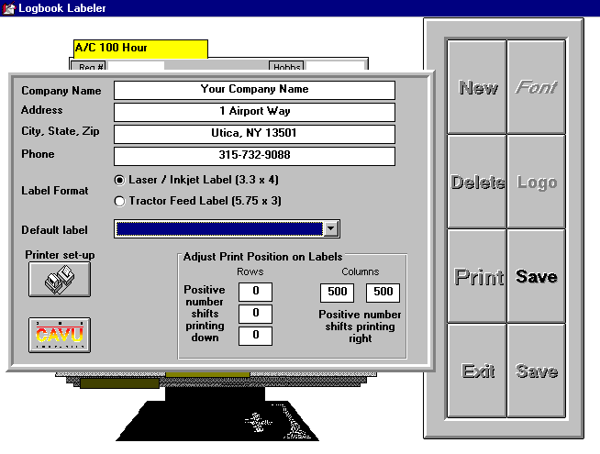

Company Information
Enter your company information, including name, address and telephone number. This information appears on the label only when the COMPANY INFO check box is filled.

Signed By
Enter the information to appear below the signature line on the label when the SIGNED check box is filled.

Default Label
Select from the pull-down list the label that should first appear when the program is started. If no labels have been saved, the pull-down list will appear empty. Save labels as below and return to this section later to set the default label.

Use this pull-down list to rapidly find a label by its title. When you exit SETUP, this label will appear.

Printer Select
Click the SELECT PRINTER button to establish the default Windows printer. If you have previously installed and selected a default printer within Windows, this step is unnecessary.

Label Position
Five (5) boxes, representing the three (3) rows and two (2) columns of laser/deskjet shipping labels (Avery 5164, 8164 / Mactec 6645 / CAVU 0600). These settings are set to 0 from the factory, however to accommodate your printer, you may need to shift the print position up or down and/or left or right. Entering positive numbers in the three vertical boxes shifts the beginning print position for that row down. Entering positive numbers in the two horizontal boxes shifts the beginning print position for that column right. Negative numbers have the opposite effect. This adjustment is only designed for small changes. Refer to your printer’s manual for information pertaining to margin adjustments etc.

SCREEN LAYOUT

The data entry screen contains a graphic image of a label organizer on the left and a panel of push buttons on the right (control panel). The organizer contains several important controls.
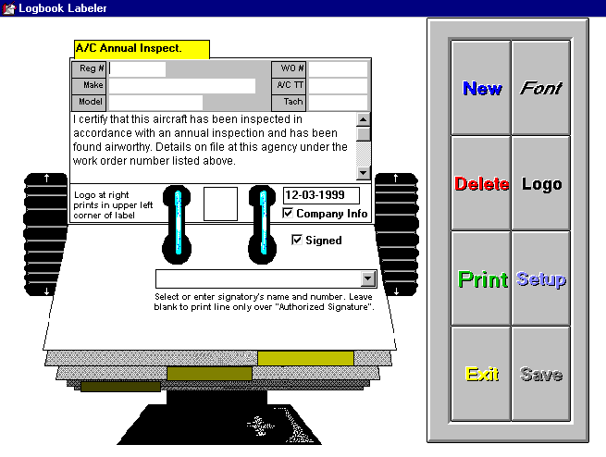

Spin Wheel
The organizer can be spun (to show labels) by clicking on the top or bottom portion of the black wheels on either side of the organizer.

Yellow Title Tag
The bright yellow label on the top of the label contains the title for that label and can be changed by over-typing it and clicking the SAVE button on the control panel. Each title can be up to 20 characters.

Gray Section
The gray section on the upper portion of the label contains six (6) user-defined input fields. By default, these fields (and their maximum size) are titled; “Reg #” (7), “Make” (30), “Serial” (13), “Tach” (8), “TT” (8) and “SMOH” (8). These titles can be changed by over-typing them or removed by deleting the character. When removed, the input field (white box to the right of the label) disappears, and clicking the SAVE button on the control panel. Each title can be 8 characters in length. Input fields left blank are not printed on the label.

White Section
The white section on the middle portion of the label contains the text of the label which is to be saved. Place the cursor within the white box and click once. Type the desired text. If a different font is desired, click the FONT button on the control panel and select a different font name, size and effect as desired. The font change effects the entire text section of the label. Remember to click the SAVE button on the control panel to save your changes. The font is specific to each label.

Below the Rings
The lower section of the label (adjacent to the “rings”) contains four (4) controls important to the appearance of the printed label.

Logo
A logo can be affixed to designated labels by clicking the LOGO button on the control panel. A map of your hard drive is displayed along with any graphic images. Select a .BMP or .ICO graphic to insert and print on the upper left corner of the label. Click the SAVE button. The graphic appearing between the “rings” will print on the label. The user is responsible for creating graphics in the format and size to appear correctly.

Date
The date can be added to each printed label. If left blank, neither a date nor the title (“Date:”) will appear.

Company Info
Company Info (name, address and phone #) can be included on the label by selecting the check box adjacent to the appropriate title. Remember to click SAVE on the control panel to save your setting. The information will appear centered on the top margin of the label. Un-checking this box moves all text up.

Signature
Each label can be footnoted with a signature line by checking the SIGNED check box. The signature line is under-titled by the entry made within the SIGNED BY field within the set-up section. It can also be selected from the pull-down list on the organizer screen.

Auto Hide Start Bar
If you are using Windows 95 and the task bar hides the buttons described above, press START and select SETTINGS. Select TASK BAR and check AUTO HIDE. The task bar will reappear whenever you drag the mouse cursor off the bottom of the screen and re-hide when you lift the mouse cursor up into the screen.

PRINTING

Label Saver
LOGBOOK LABELER utilizes “Label-Saver” to allow the repetitive use of multi-label forms. Avery label 5164 contains six (6) labels on one sheet. When PRINT is pressed, the “Label-Saver” window appears with the first label position unchecked. The 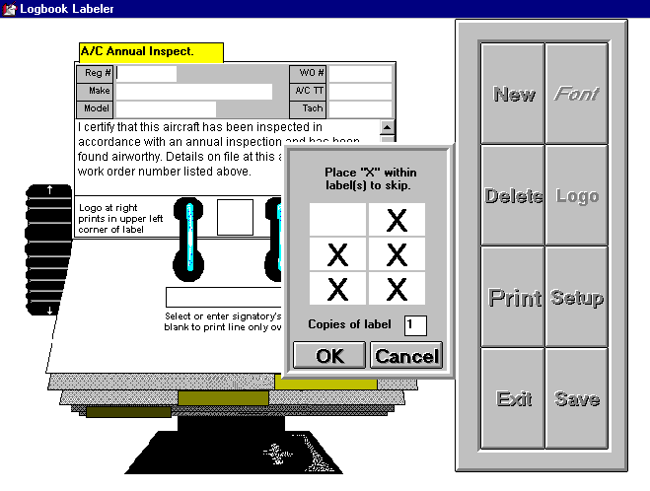remaining label positions contain “X”s, signifying that the label will not be printed in these positions. To select or deselect a label position, move the mouse cursor over the box and press the left mouse button. An “X” will alternately appear.

Number of Labels
Enter the number of copies to print. The default number is one (1).

When the desired labels are selected, press OK to continue.

If multiple labels are needed to print the text or more than one copy is selected, the next label available (according to “Label-Saver”) will be used. In cases where only one label is available to print (all but one box is checked), a second sheet of labels is used.

How To…

Make A New Label Template
To make a new label template, press the NEW button.
- Enter a title for the label, up to 20 characters in length. ie. C-172 Annual
- Modify, if necessary, the titles to the six input fields. To modify the title, click on the title with the mouse cursor. Highlight the existing text and re-type the desired text (8 characters max.)
- Enter the text to be used as the template. The text will automatically wrap when it gets to the left margin. Put in carriage returns (ENTER key) only where desired.
- Use the FONT button to change the appearance of the form.
- Select a logo for the label by pressing the LOGO button, optional.
- Select whether or not your company information should appear on the label top.
- Select whether or not the label should contain a signature line.
- Press SAVE to keep your new label.

Use The Template To Print A Label
- Find the template desired by using the scroll buttons, ie. C-172 Annual
- Enter the data in the appropriate boxes (i.e. N1234Z next to the Reg. # box)
- Modify the text within the label if necessary for the procedure. See below about saving this template.
- Use the FONT button to change the appearance of the form.
- Select a logo for the label by pressing the LOGO button, optional.
- Enter the date, if any, that should appear on the label.
- Select whether or not your company information should appear on the label top.
- Select whether or not the label should contain a signature line.
- Select the mechanic’s name to print below the signature line.
- Click on the PRINT button.
- Select the print position and the number of labels to print.

Fonts
The text section font size can be adjusted by clicking on the font button when the desired label is displayed. A font selection screen appears. Select the desired font and note the change in appearance on the label. When the desired font appears, save the label and the font setting will be saved for that label.
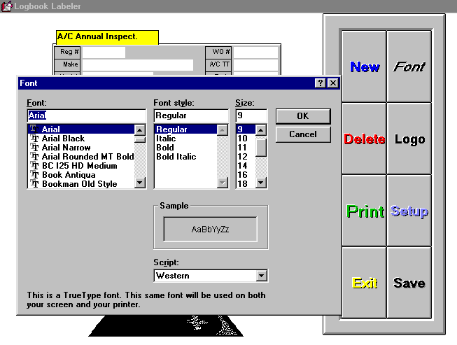

Save
The SAVE button saves only the template of the label. In other words; the text, user-defined titles, check box settings and format (font, etc) of the label are saved, but the input fields (to the right of Reg #) are not. Therefore, it is not necessary to press SAVE after entering data into the input fields. If you make “one-time” entries into the text section, for instance to elaborate on a specific procedure performed, then you should not press SAVE. If you do press SAVE, the text section will include the new procedure description as well. If you want to have both labels, press NEW and create a second label with an appropriate title.

Exit
To exit the program and return to the PROGRAM MANAGER (of Windows 3.x) or Your Desktop (of Windows 95), press the EXIT button. This removes LOGBOOK LABELER from memory and the LOGBOOK LABELER icon must be pressed again to restart the program.

Note: LOGBOOK LABELER can remain in resident memory while other Window applications are run by starting LOGBOOK LABELER as normal and pressing ALT + TAB to switch back to Program Manager without exiting LOGBOOK LABELER.
If you exit LOGBOOK LABELER without saving, any modifications or entries made on the displayed form will be lost and must be re-entered.
A message box appears to confirm your intentions.

Delete
The on-screen DELETE button deletes the entire form appearing on the screen. It is active only with previously saved forms. When pressed, a message box will appear to confirm your intentions.

Learn More about CAVU
The CAVU logo button, located on the SETUP screen, displays important information about other products offered by CAVU, technical and copyright information. Click the CAVU logo to display and turn off the screen.

Corrupted Databases

General
From time to time, it may be necessary to repair (and occasionally compact as well) the database containing your information. If the program fails to save a form or an error message appears stating that the database is not a Microsoft Access database follow the directions in order below.

Steps to Repair a Database

For Windows 3.1
Go to Data Manager (usually found within DESK MANAGER SERIES group. If not found within this group, use the File Manager to locate the Datamgr.exe file and double click on it)

For Windows 95 and higher
Go to START / PROGRAMS / DESK MANAGER SERIES and select Data Manager (If not found within this group, use the Windows Explorer to locate the Datamgr.exe file and double click on it)
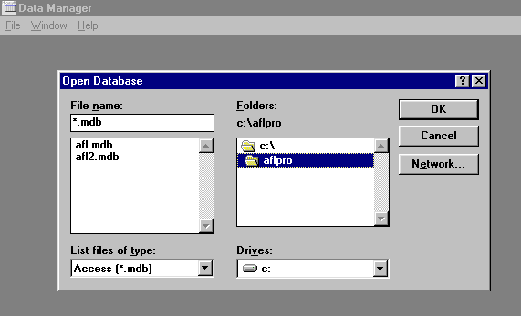
- The screen will blank, except for a menu bar displaying FILE WINDOW etc. Select REPAIR DATABASE
- A two-window panel with the title DATABASE TO REPAIR appears. Above the right window, the current location is listed (i.e. C:\aflpro). If this is not the correct location for the file you are attempting to repair (refer to chart below), use the list in the right window to select the correct location. Double click on the open folder C:\ icon to show all subdirectories.

Default subdirectories and MDB files for CAVU products
CAVU Program | Default Subdirectory | Filename(s)
Form 337 | C:\FORM337 | Form337.mdb
Form 8110-3 | C:\Form8110 | Form8110.mdb
Form 8130-3 | C:\Form8130 | Form8130.mdb
Form 8710-1 | C:\Form8710 | Form8710.mdb  8710.mdb
Form 8060-4 | C:\Form8060 | Form8060.mdb  Setuptac.mdb
Weight & Balance (fix) | C:\WBW | wb.mdb
Logbook Labeler | C:\Loglabel | Logbook.mdb
MTR Pro | C:\mtrpro | mtr.mdb
AFL Pro | C:\aflpro | afl.mdb  afl2.mdb
Weight & Balance (heli) | C:\WBWHeli | wbheli.mdb

- With the correct location listed on the right directly under the word FOLDERS, the left window will fill with MDB files (files that end with the letters MDB). Select the file to repair and press OK. Repeat these steps for each MDB file.
- You may now exit the Windows Explorer and restart your program or proceed to COMPACT the database per the instructions below.

Steps to Compacting a Database

- First perform Repair Database (see above)

For Windows 3.1
Go to Data Manager (usually found within DESK MANAGER SERIES group. If not found within this group, use the File Manager to locate the Datamgr.exe file and double click on it)

For Windows 95 and higher
Go to START / PROGRAMS / DESK MANAGER SERIES and select Data Manager (If not found within this group, use the Windows Explorer to locate the Datamgr.exe file and double click on it)
- The screen will blank, except for a menu bar displaying FILE WINDOW etc. Select COMPACT DATABASE
- A two-window panel with the title:
DATABASE TO COMPACT FROM
Above the right window, the current location is listed (i.e. C:\aflpro). If this is not the correct location for the file you are attempting to compact, use the list in the right window to select the correct location.
- With the correct location listed on the right, the left window will fill with MDB files (files that end with the letters MDB). Select the correct file to compact and press OK.
- The two-window panel will now reappear with the title:
DATABASE TO COMPACT TO
In the left window select the file you are compacting again. Its name will appear in the box above labeled File Name. Change the last three letters from MDB to NEW making sure that you leave the dot preceding the MDB. Then press OK
- Close Data Manager.

For Windows 3.1
Go to File Manager (usually found within MAIN group)

For Windows 95 and higher
Go to START / PROGRAMS and select Windows Explorer
A two-window screen will appear. Select the subdirectory on the left where you found the database files.
- The file name(s) with the last three letters NEW should appear on the right. Be sure the files exist before proceeding. Right click and DELETE the original file(s) with the MDB ending. Right click on the file ending with NEW and select RENAME. (If no file extensions appear, go to VIEW / FILE OPTIONS and uncheck any selections that hide file names.)
- Keeping the part of the file name before the dot the same, change the letters NEW to MDB (retain the dot) and press ENTER.
- You may now exit the Windows Explorer and restart your program.

Troubleshooting Guide
Problem | Solution
DDEML.DLL can not be copied. | This message sometimes appears when installing the program. Press IGNORE or OK. If the program installs completely, there is nothing more to do. If the installation terminates before completion, you must turn off all programs running within Windows, such as screen savers etc., then re-install the new program.
Keeps asking me for my registration code. | When installing the program, you are asked to enter your telephone number as it appears in the back of your manual. Notice that the number is not preceded by a “1”. If the number was entered incorrectly, you must re-install your software.  If the phone number was added correctly, the registration must be entered in CAPS. To edit this entry, select RUN from the FILE pull-down list (Windows 3.1) or RUN from the START button (Windows 95). Enter SYSEDIT and press OK.  A window will appear with several index cards. The top card is entitled AUTOEXEC.BAT. The first line should read:  SET <name>=XXXXXXXXX  where <name> is the appropriate program name (and seldom requires altering) and XXXXXXXXX is the registration code in CAPs. If the line appears correct, look for subsequent lines that begin with SET <name> and remove them by placing the cursor in front of the line and pressing the DELETE key. Do not remove any other lines except lines beginning with SET<name>. Note that there may be a line starting with SET TEMP. Do not remove this line.  Once the line is entered correctly, select SAVE from the FILE pull-down list WITHIN the window that appeared with the index cards.  Exit this window by selecting EXIT from the FILE pull-down list.  Exit Windows and turn your computer off. You may now restart Windows.
SHARE.EXE not installed or locks exceeded. | If you are using Windows for Workgroups or Windows 95, you should not see this message. Other Windows users need to install the program SHARE.EXE.  To install this program, select RUN from the FILE pull-down list. Enter SYSEDIT and press OK.  A window will appear with several index cards. The top card is entitled AUTOEXEC.BAT. Select SEARCH from the options at the top of the window. Enter the word SHARE and press ENTER. If the word is not found proceed with A below otherwise proceed with B.  A. Place the cursor on any line before the line that contains the command WIN. If no line contains the command WIN, place the cursor anywhere . Be sure the cursor is at the beginning of the line you are on. Press ENTER, an empty line should appear. Place the cursor at the beginning of that line and type  C:\DOS\SHARE.EXE /L:500  Note: sometimes the share.exe program is not found within the DOS subdirectory, as the line above assumes. If it is not within the DOS subdirectory, consult your computer expert to find the file. Go to C  B. The SHARE.EXE command must be followed by a space, then a /, and finally an L:500  C. It is not necessary to press ENTER after the entry, but if you do, no harm is done. Select SAVE from the FILE pull-down list WITHIN the window that appeared with the index cards.  Exit this window by selecting EXIT from the FILE pull-down list.  Exit Windows and turn your computer off. You may now restart Windows.
MDB is not access database or database is corrupt | See Corrupt Databases above
Only prints boxes without text or text missing | See INVALID PROPERTY VALUE below.
Invalid Property Value | This message occurs when fonts have not been installed. Select FONTS from within the CONTROL PANEL group. Windows 3.1 will display installed fonts. Press the ADD button. Windows 95 users should select INSTALL NEW FONT from the FILE pull-down list. Within the lower window, double click on the SYSTEM subdirectory. Numerous fonts should appear. Press the SELECT ALL button, then click on OK. A message may appear for each font already installed. Simply press OK until the INSTALLED FONTS viewer re-appears. Exit this section and retry your program.

